**A Dynamic Model of Urban Food Waste and Composting**

**By: *Shehab Hasan***

**Co-Authors***:* ***Digna Trivedi***

***Shraddha Lakhani***

***Sajit Thomas***

***Akshay RK***



**Table of Contents**

1. Problem Articulation
   1. Theme Selection
   2. Key Variables and Concepts
   3. Time Horizon
   4. Dynamic Problem Definition / Reference Modes
2. Formulation of Dynamic Hypothesis
   1. Initial Hypothesis
   2. Endogenous Influences and Structure
   3. Mapping
      1. Model Boundary Diagram
      2. Subsystem Diagram
      3. Causal Loop Diagram
      4. Stock and Flow Diagram
      5. Policy structure diagrams
3. Simulation Model
   * 1. Specifications
     2. Estimation
     3. Tests
4. Testing
   * 1. Testing vs Reference Mode
     2. Robustness under Extreme Conditions
     3. Sensitivity
5. Policy Design and Conclusion
   * 1. Different scenarios and given uncertainties
     2. Policy design:
     3. “What if. . .”
     4. Sensitivity analysis:
6. Summary

**Abstract**

Food waste is one of the major issues in the world today. And when the food is wasted, every effort done to produce, packed, processed etc. is wasted too. Moreover when food is landfilled, it becomes significant source of methane. This causes air pollution and it causes diseases and other adverse health effects. The statistics shows that even if you reduce 15% of food waste every year it would be great impact on environment and also that food can be used to feed thousands of people. The food wastage has been increased from last couple of years and now has become major issue all over the world.

1. **Problem Articulation**

Theme Selection:

In past years, food waste had receive Expanding interest from all over the world like local, national and policymakers, worldwide associations, NGOs as well as academics from different disciplinary fields. The most complex one from all solid waste is urbane food waste. The causes are because of the change and opening up to the outside world, with the speed advancement of the social economy in world, progressively enhancing living standards, improvement in urbanization process and increasing migration of population and stream toward urban communities, and consumer behavior. Effects of those are wastage of 1/3 of world fertile land area, biodiversity loss, carbon footprint with billions of tons of greenhouse gas emission, climate change and economic consequences.

Key facts on food waste worldwide are:

* Globally one third of the food produced in the world for human consumption every year — approximately 1.3 billion tones — gets lost or wasted.
* Food losses and waste amounts to roughly US$ 680 billion in industrialized countries and US $310 billion in developing countries.
* Americans throw away $165 billion of food each year.
* 35 million tons of food are wasted in the United States each year.
* The average American household throws away $2,200 of food each year.
* 90% of food is thrown away too soon.
* Food waste in American’s has grown by 204% since 1960 and 50% since 1990.

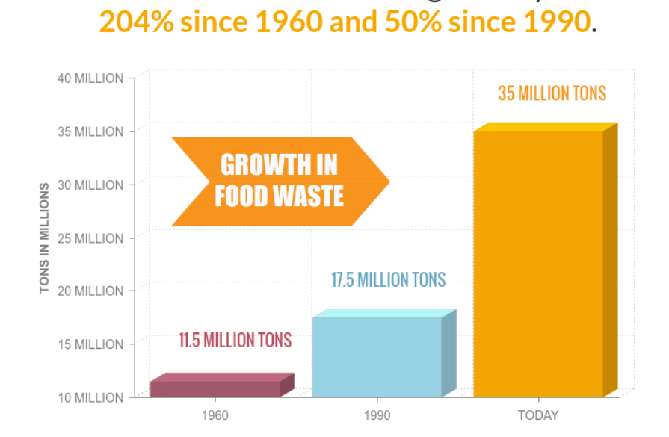

* Reducing food waste by just 15% would be enough to feed more than 25 million Americans every year.
* Fruits and vegetables, plus roots and tubers have the highest wastage rates of any food.

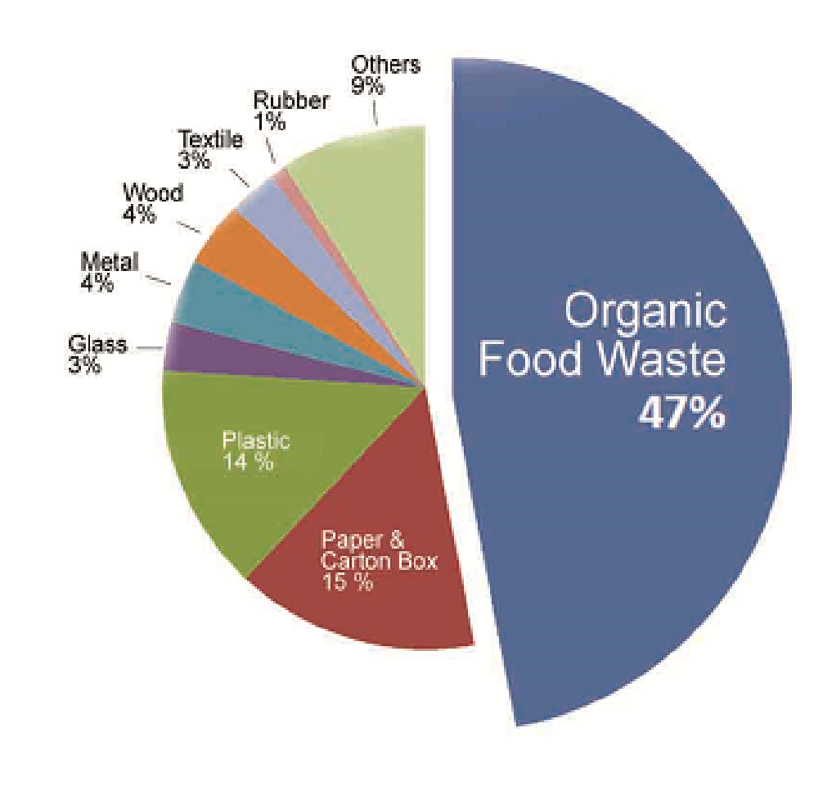

Figure 2. Types of waste in America

Disadvantage of landfills

* It pollutes the soil and groundwater with toxins.
* Releases methane and greenhouse gases which cause health problems.
* Methane is highly flammable and causes explosions in near buildings
* It also causes diseases and illness.

Advantages of decomposition

* It creates rich soil which helps to retain nutrients, moisture and air for the plants.
* It also decreases a household’s greenhouse gas emissions.
* Food waste is 70% water so it would be best option to send it to plants
* It can also be used to generate power and electricity at treatment plans

Cleveland Food waste

Up to 90 percent of waste thrown out by supermarkets and restaurants is food scraps. In fact, food scraps are the third largest segment of the waste stream, with nearly 26 million tons generated each year.

Unfortunately, it is also the least recovered. If the 26 million tons of food scraps generated annually were composted rather than landfilled, greenhouse gas emissions would be reduced by more than 21.5 million metric tons carbon dioxide equivalent. This savings is equivalent to the removal of more than 4 million cars from the roadways each year, conserving more than 2 billion gallons of gasoline, or providing annual electricity needs to more than 2.5 million homes!

Researchers studied more than 20 food groups and found that fruits and vegetables accounted for 39 percent of all food waste

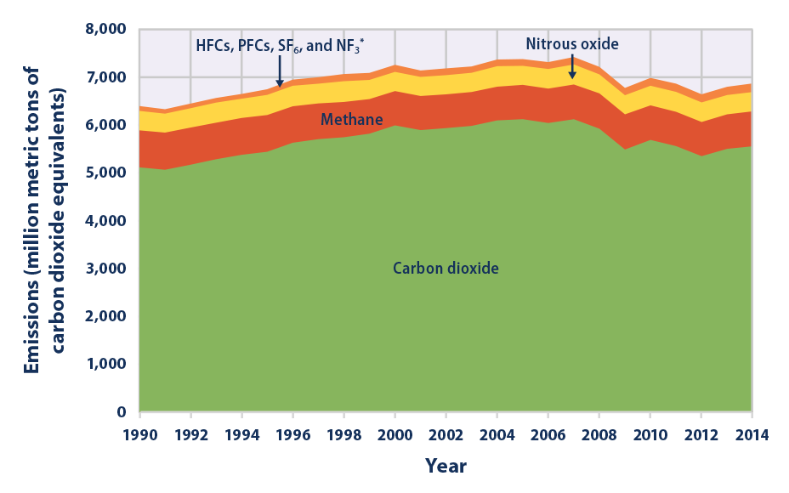

**Time Horizon**

* Every year, countries create 1.3 billion tons of waste. That is required to take off to 4 billion tons by 2100, as indicated by Ede Ijjasz-Vasquez, senior chief for the World Bank's Social, Urban, Rural and Resilience Global Practice.
* In the early 20th century, farmers like Sir Albert Howard (known as the father of modern organic farming) applied new information of microbiology to compost practices and started creating some of the thickest fertilizer ever. He helped pioneer modern composting by building the Indore Method. He advanced organic farming throughout his life and helped spread composting advocacy across the world. Composting reduces waste, reuses natural materials, and advances healthy,organic, sustainable agriculture. This conversion began as early as the 1850s, when Stephen Hoyt and Sons, of New Canaan, Connecticut, famously composted over 200,000 fish and 17,500 bushels of manure in a single season. Edwin Hoyt, presumably one of the sons, said of this strategy: “With this manuring, no matter how poor the soil, the rye will be as large as a man  
  can cradle.”
* Since the 1980s, this country started the next stage of waste management, an integrated waste management (IWM) approach. A set of administration choices were produced that  
  focus on the three Rs of IWM, recycling, reusing, resource reduction.  
  Alternatives also include expanding composting and incineration. This other  
  view on waste disposal has been slow to mature as landfills still dominate the  
  waste disposal scene, but their use has declined from accepting 90% of the  
  solid waste generated by regions in 1980 to 45% today.
* Since 2000, the World Bank has contributed about $4.5 billion to support 329 solid waste programs around the world. They include tasks such as junk collection and disposal, reuse and recycling, and activities aimed at changing habits related to waste.The U.S. produced about 228 million tons of waste in 2006, a figure that increased to 254 tons by 2013. China (with a population around four times larger than that of the U.S.) is not far behind, with 190 million tons of waste per year.
* The more urbanized and industrialized a nation turns into, the more junk it produces, Ijjasz-Vasquez said. The United Nations Environment Program predicts the amount of waste will presumably double in lower-salary African and Asian cities as a result of  
  population growth, urbanization and rising utilization. Composting did not end  
  with the American Revolution. Like agriculture in general, however, composting  
  strategies have moved from small farming operations to industrial-scale  
  facilities. Today, cities large and small undertake municipal compost  
  operations; New York City recently implemented an experimental pilot program to  
  gather curbside compost.
* The biggest disadvantage of fertilizing with compost is that it takes devoted individuals and hard labor to maintain healthy compost piles. Chemical fertilizers provided an easier way to grow more and grow faster. However, they’re also full of icky substances  
  that can be harmful to both the environment and human well- being. Excess  
  nitrates saturates into bodies of water and cause algal blooms, ammonium  
  nitrate can be highly explosive under the wrong conditions, and majority of the  
  chemicals used to make these composts come from non-renewable resources including  
  natural gas, Chemical composts have caused soil depletion, groundwater contamination, soil fermentation, fungi depletions and other ecological problems for more than 100 years. These issues have turned out to be so serious that the United Nations has pronounced 2015 to be the “International Year of Soils”. The objective of this initiative is to  
  bring issues to light about the way that healthy soil provides the foundation  
  for, well, everything- all food and therefore all human life. Soil is viewed as  
  a nonrenewable resource, and according the UN, about 33% of Earth’s soils are  
  moderately to severely degrade- thanks, in part, to chemical fertilizers and  
  intensive agriculture. Though it may help plants grow fast and resilient,  
  chemicals do not provide the organic humus that many plants have been  
  acquainted to growing in for thousands of years. And damaged soil is hard to  
  remediate. As President Franklin D. Roosevelt once said, “A country that  
  demolishes its soil destroys itself.” Because it is all-natural and supports  
  soil instead of destroying it, compost is the superior plant fertilizer. And as  
  our understanding of composting grows, we’re figuring how to make the way of  
  composting simpler and more boundless.
* Several research experimental studies were conducted on composting in a silo-type digester using mechanical blending. The after-effect of this work exhibited that a generous amount of consideration had been paid to the improvement of more efficient mechanical mixing and to the solution of mechanical problems associated with digester activities. Silo digesters had been used fundamentally in relatively small installations for  
  isolated waste having a high concentration of organic matter. The processing  
  units were largely mechanized to give continuous aeration and were intended to  
  reach thermophilic temperatures to achieve rapid degradation.
* Fertilizing the soil fundamentally diminishes the amount of waste we send to landfills. According to the United States Environmental Protection Agency approximately 30% of landfill waste consists of organic food waste that could be composted. When food ends up in landfills it becomes a major source of methane, a potent greenhouse gas.  
  Composting has different natural environmental benefits incorporating the  
  increase in drought resistance, soil well-being, and the decreased requirement  
  for pesticides and fertilizers. In addition indirect improvements from  
  composting include better sanitation and public safety reducing bad odors from  
  trash cans and dumpsters. Microbes found in compost also break down toxic  
  organic compounds such as 3 petroleum and improve CEC (cation exchange  
  capacity) holding more supplements in the soil for plant utilize.

**2**. **Formulation of Dynamic Hypothesis**

* 1. **Initial Hypothesis**
* The problem of food waste is not just begun but has been there since early stages. Companies are always producing food more than required. It has become economic and environmental problems
* As industries are only focusing for separation of waste, landfills have increased. Today people are more doing landfills than the composting because no one is aware of the dangerous effect of the landfills
* Increase in urbanization and population has caused severe high percent of landfills which are kept unattended and so changes into pollutions
* Our system here is focused on this problem of reducing landfills and increasing composting.

**2.3.1 Model Boundary Diagram**

|  |  |  |
| --- | --- | --- |
| Total food waste in city  Portion of food waste sent for composting  Portion of food waste sent to landfill  Total composting capacity  Compost in production  Number of batches  Batch capacity  Unit production cost of soil  Funds  Finished compost (to use/sell)  Available capacity for food waste  Current amount of decomposing food waste  Current amount of woodchips/carbon sources  Storage capacity of woodchips/carbon sources  Available capacity of woodchips/carbon sources  Compost quality | Size of food market  Weather  Waste management regulations  Influx of woodchips / carbon sources  Demand for compost | City population  Personal/small scale composting  Origin of food |

**2.3.2 Subsystem Diagram**

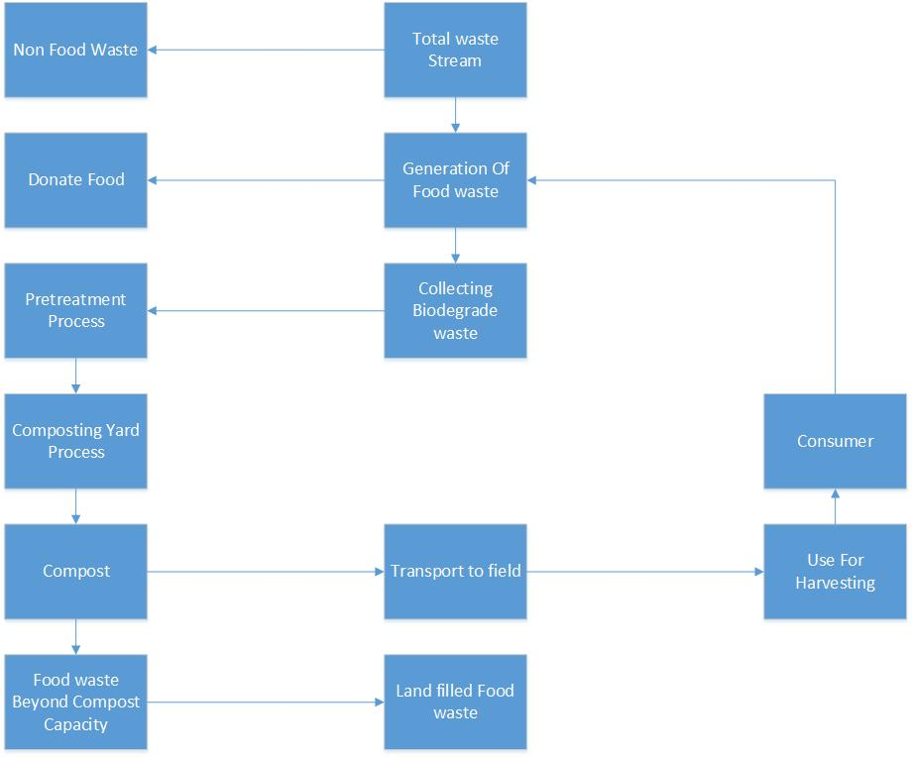

**2.3.3 Causal Loop Diagram**

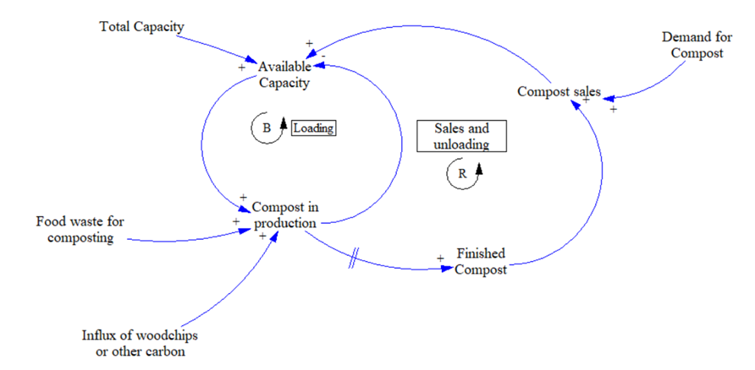

* 8 month delay between compost in production and finished compost.
* Self-balancing loop based on limits of capacity.
* Low level model helps create reference modes for available capacity in more abstract models.

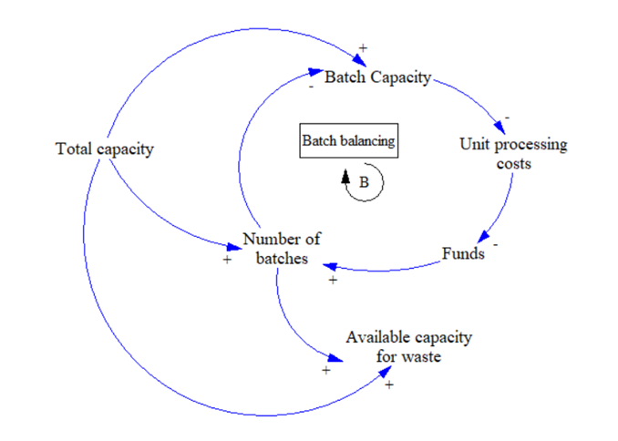

* Once a batch begins composting, no new food waste can be added until composting is completed and all the soil is used.
* Multiple batches are therefore required to allow consistent capacity for food waste.

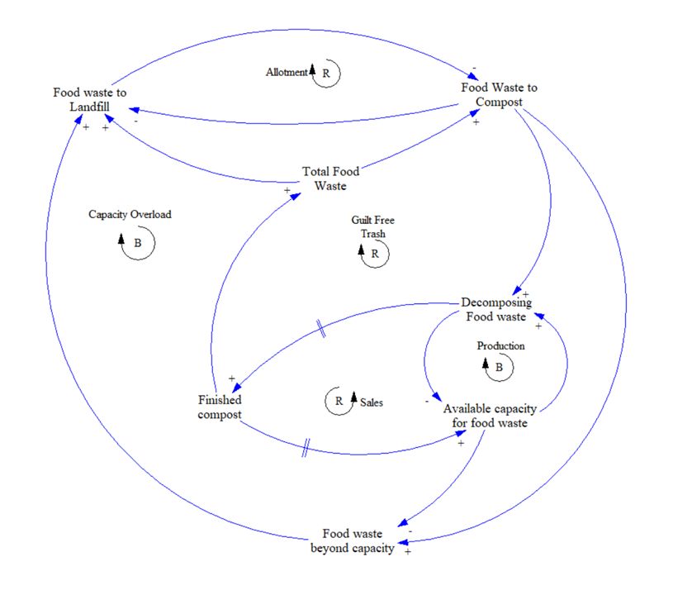

Higher level causal loop with policy resistance

**Stock and Flow Diagrams and Simulations**

To better understand the dynamic behavior of composting, we shall first use a stock and flow diagram from to simulate the behavior of a single composting facility. This stock and flow diagram will highlight potential issues with composting programs and form the basis of more complex food waste stock and flow diagrams.

Compost Facility Stock and Flow Diagram

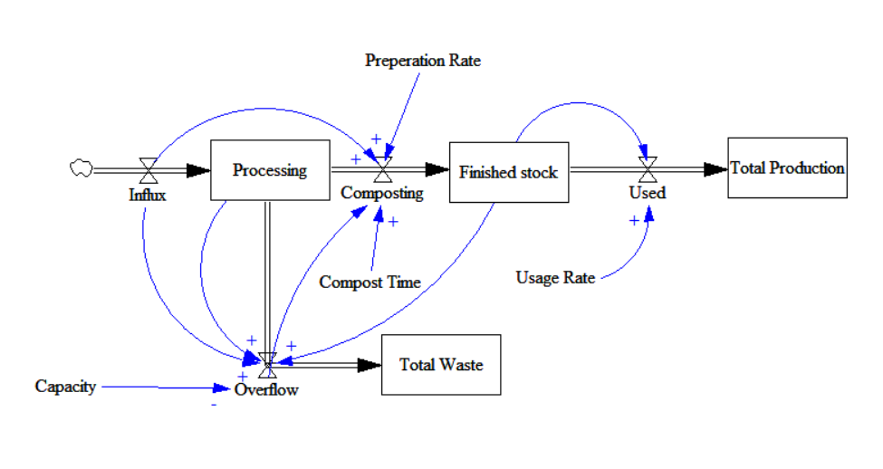

Influx (of food waste) goes to the stock of processing compost if possible, otherwise becoming overflow and contributing to total waste. After spending 24 weeks composting, the processing stock becomes finished stock, which is later used (either in house or sold). Total production measures all the compost made and used. The combined processing and finished compost stocks cannot exceed the capacity.

This stock and flow diagram was simulated based off the experience of the Rid-All urban farm. The simulation output graphs provide insight on desired composting conditions.

Influx and preparation rate are set to 3 tons/week, and compost time is 24 weeks.

Compost Facility Simulation - Ideal

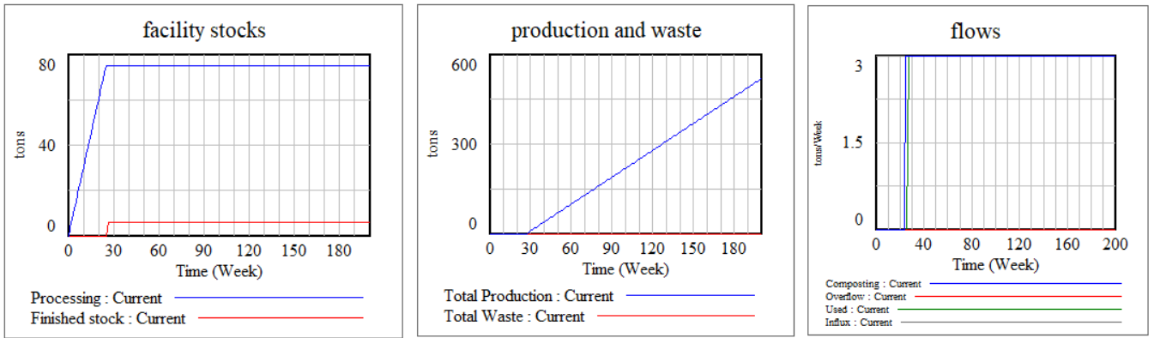

Capacity = 100 tons, usage = 3 tons/week - capacity is large enough that there is no backlog of stock due to processing time, and usage rate matches influx so stock does not accumulate

Compost Facility Simulation – Low Capacity

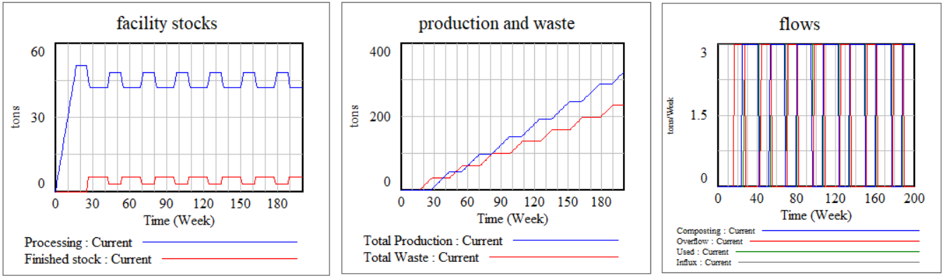

Capacity = 60 tons, usage = 3 tons/week: the capacity is not enough to handle the rate of influx accumulating for 24 weeks to completely compost. The result is oscillatory behavior as finished compost frees capacity and new influx then fills that capacity.

Compost Facility Simulation – Low Usage, High Capacity

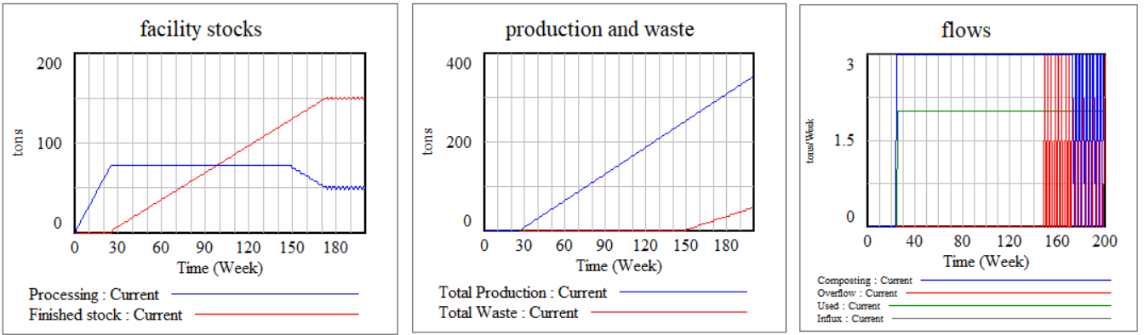

Capacity = 200 tons, usage = 2 tons/week: The large capacity helps prevent wastage for a while, but eventually the stock of unused finished compost results in overflow.

Compost Facility Simulation – Low Usage, Low Capacity

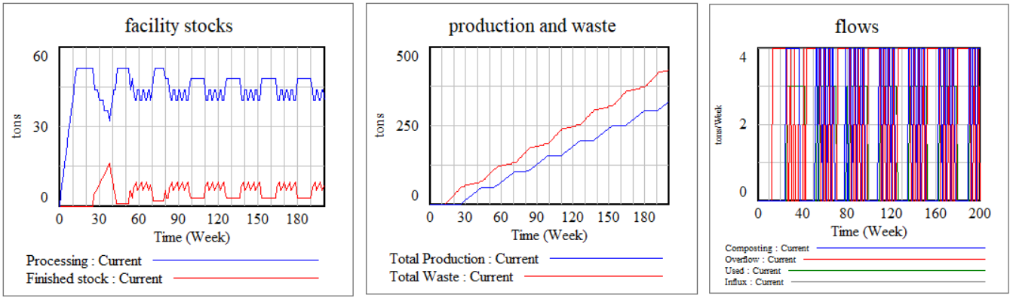

Capacity = 30 tons, usage = 2 tons/week: more extreme oscillatory behavior and significant overflow and waste

Municipal Waste Management Stock and Flow Diagram

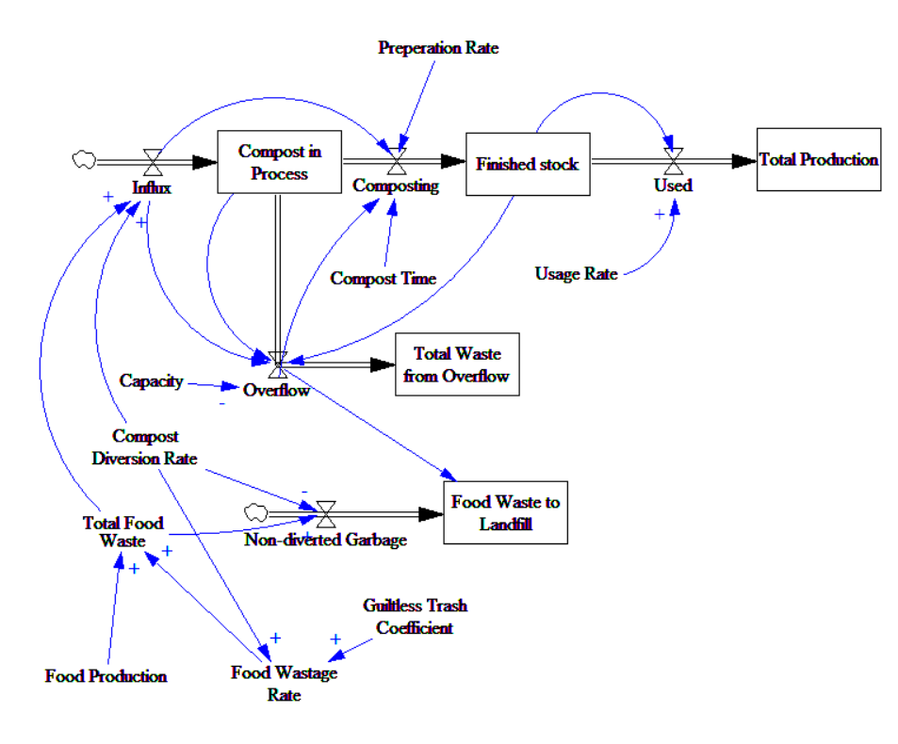

This stock and flow diagram incorporates the facility stock and flow model but no longer treats food waste influx as an exogenous variable. In this diagram, food production is exogenous and is simulated using reference modes. Total food waste is equal to food production * food wastage rate, and influx is equal to total food waste * compost diversion rate. Food wastage rate represents the portion of food produced that is ultimately thrown away, and compost diversion rate is the portion of that thrown away food that is properly sorted and set for composting.

Policy resistance is modeled by the positive relationship between food wastage rate and compost diversion rate. This represents people feeling less pressured to use food instead of throwing it away when they think their food is being recycled into compost instead of being thrown into a landfill. In the following simulation, increasing the compost diversion rate at first lowers the amount of landfill waste, but further increases in compost diversion increases the amount of landfill waste.

For this simulation, capacity = 100 tons, compost time = 24 weeks, preparation rate = 3 tons/week, usage rate = 4 tons/week, guiltless trash coefficient = .1, food production is a reference mode that starts at 20 at t=0 and goes to 30 at t=200

Compost Diversion Rate = .3

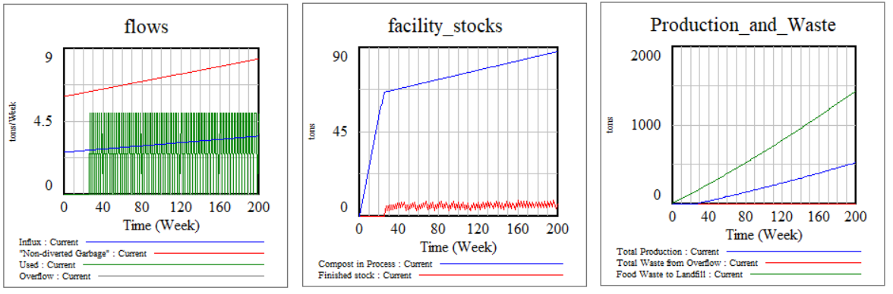

Compost Diversion Rate = .4

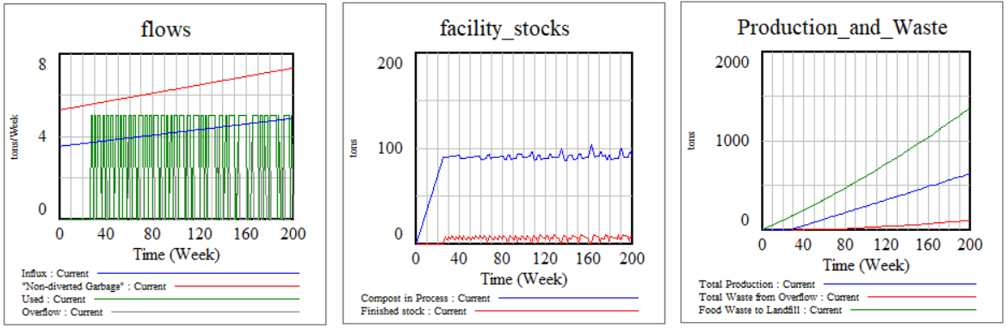

Compost Diversion Rate = .5

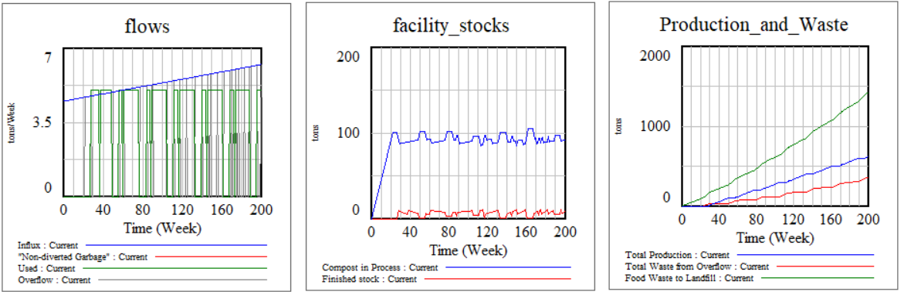

The capacity and usage rate limit any further increases in compost production, but people are more likely to throw away food than before. This suggests that a proper policy response must include interventions to increase capacity of compost facilities and usage rate of compost in proportion to the increase of diverted of food waste.

**Policy Structure Diagram for Food Waste Management**

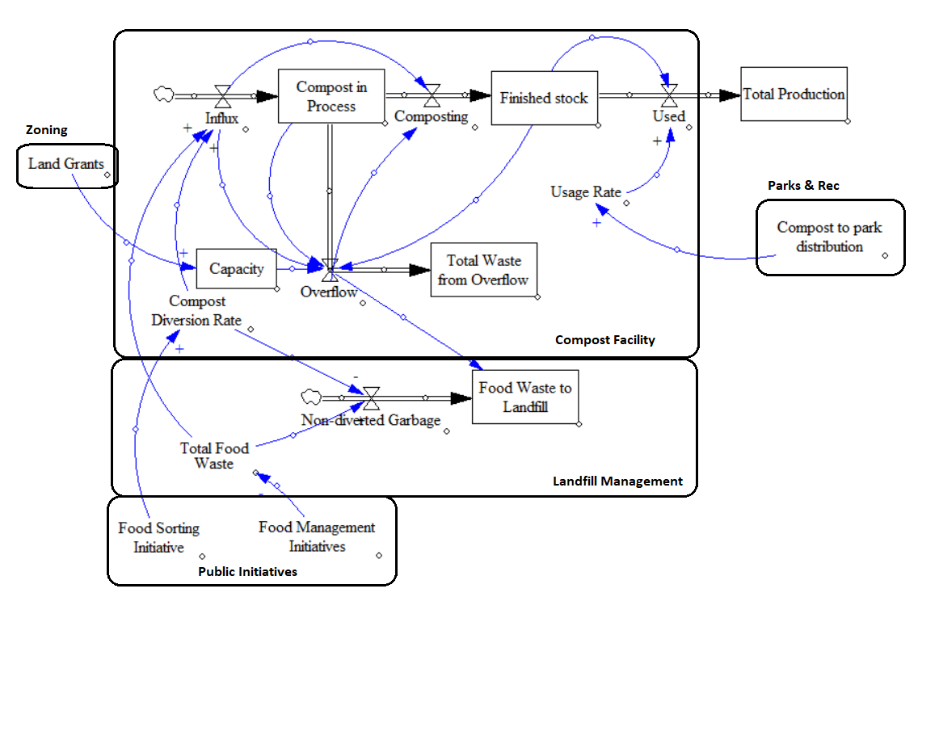

Our policy recommendations include public initiatives to decrease food waste and improve sorting efforts to divert more food waste to composting programs. It also includes policy recommendations to ensure that composting facilities can handle increases to food waste influx by zoning out land for the purpose of compost capacity and by removing finished compost in these facilities for use in public parks. This measures are necessary to prevent issues we found in the simulation model that result from have too low capacity, too low usage, or both.

Municipal Food Waste Stock and Flow Diagram with Policy Modeling

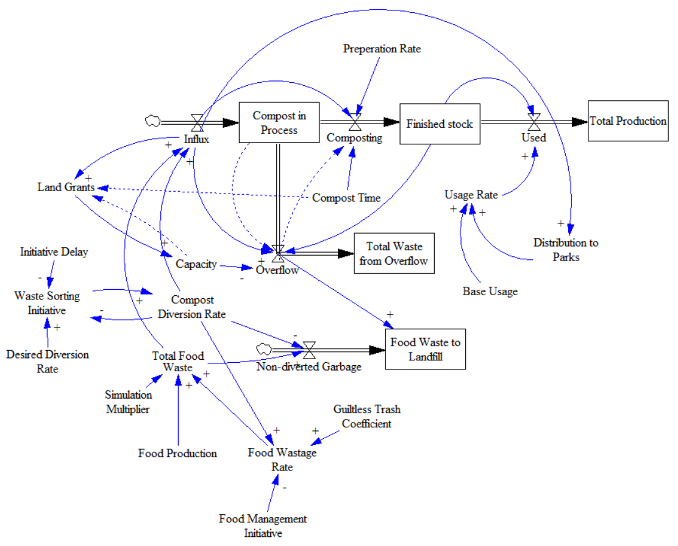

Modeling policy recommendations

Land grants are recommended to be awarded in proportion to influx, but only when current capacity is insufficient.

Waste sorting initiative drives the compost diversion rate towards the desired diversion rate in an exponential decay function. Initiative delay impacts the rate of change of the diversion rate.

Distribution to parks is also tied to influx (in this model, equal to half the influx) and contributes directly to usage rate.

Food Management initiative is a variable that proportionately reduces the food wastage rate.

Simulation Multiplier has no real world policy implication – it is used to make simulating the model under different conditions easier. It simply multiplies the total food waste by a given factor.

Model configurations

Food management initiative is a reference mode that starts at 1 and goes down to .75 over the model’s 4 year simulation run.

Food production is a reference mode that starts at 20 and increases to 30.

Initial capacity is 100 tons

Initial compost diversion rate is .2

All other stocks are initialized at 0

Base usage is a random number between 0 and 8 (to model the unpredictable nature of sales)

Other variables are on a slider and manipulated to simulate the model under various conditions

Initiative Delay = 52 weeks, Desired Diversion Rate = .5, Simulation Multiplier = 1, guiltless trash = .05

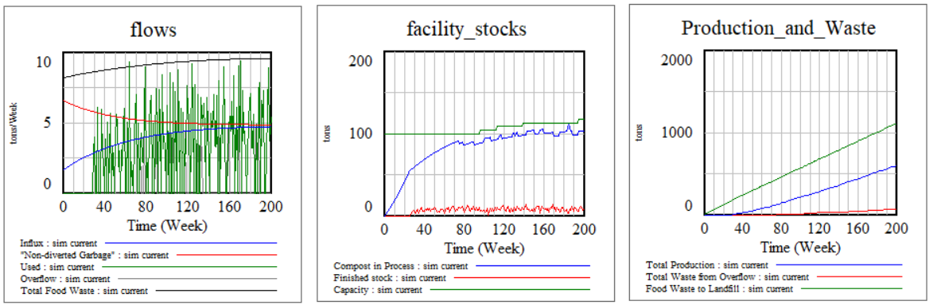

The escalating diversion of food waste requires capacity increases. What if the initiative delay was longer?

Initiative Delay = 156 weeks, Desired Diversion Rate = .5, Simulation Multiplier = 1, guiltless trash = .05

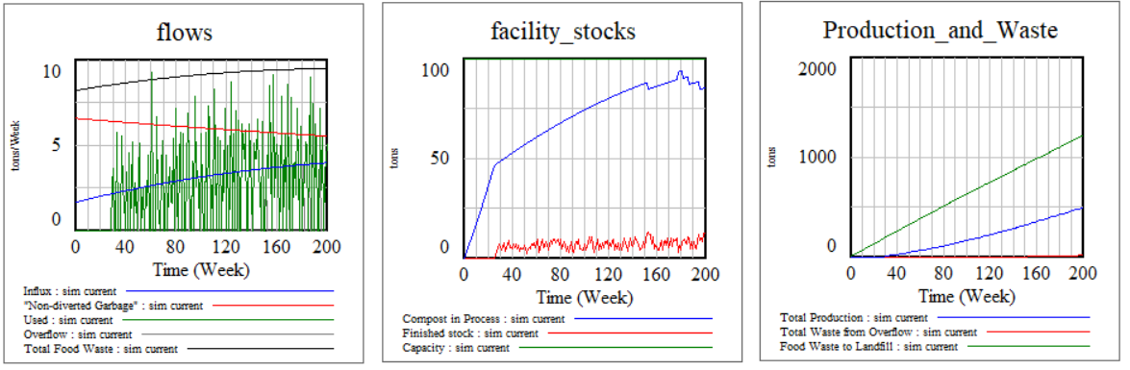

Food waste is not being diverted fast enough to necessitate capacity increases.

Initiative Delay = 52 weeks, Desired Diversion Rate = .5, Simulation Multiplier = 3, guiltless trash = .05

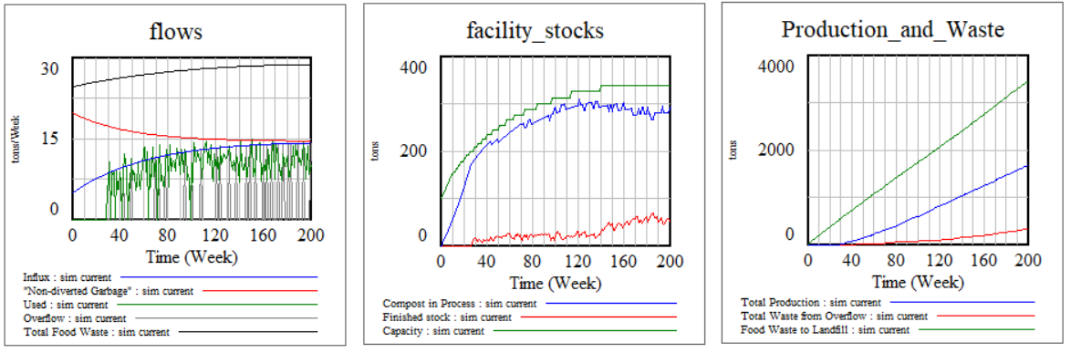

The simulation multiplier greatly increases the influx and these conditions would have easily overwhelmed our compost facility without our policies implemented. However, tying capacity growth and usage rate to influx allows our simulated model to handle this growth much more elegantly than otherwise.

Initiative Delay = 26 weeks, Desired Diversion Rate = .5, Simulation Multiplier = 5, guiltless trash = .1

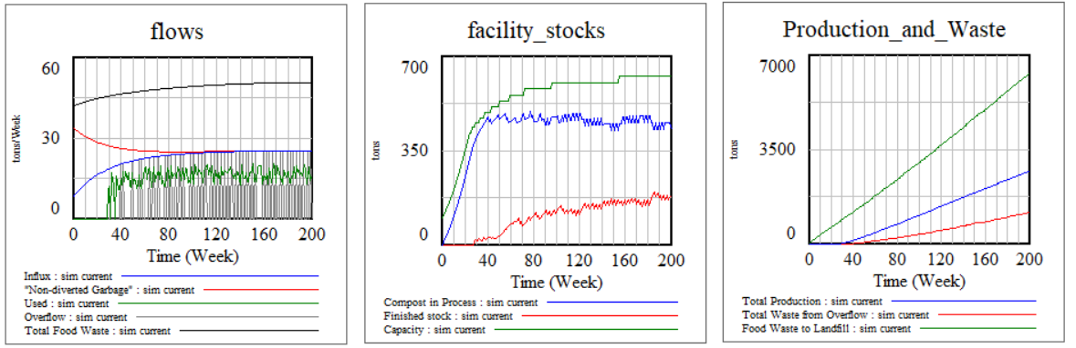

Pushing the simulation multiplier (and therefor influx) higher highlights some limitations of the model as currently configured. Distribution to parks is set only to half the influx rate, and base usage is low enough that compost begins to stockpile on sight. A more robust policy would include other usage initiatives in response to the growth of stockpiled compost if the market was otherwise insufficient.

Vensim Equations

**Compost facility model**

(01) Capacity=

100

Units: tons

(02) Compost Time=

24

Units: Week

(03) Composting=

DELAY FIXED( Influx-Overflow , Compost Time + (Influx-Overflow)/Preperation Rate

, 0 )

Units: tons/Week

(04) FINAL TIME = 200

Units: Week

The final time for the simulation.

(05) Finished stock= INTEG (

Composting-Used,

0)

Units: tons

(06) Influx=

3

Units: tons/Week

**Food waste management**

(01) Capacity=

100

Units: tons

(02) Compost Diversion Rate=

0.3

Units: **undefined** [0,1,0.1]

(03) Compost in Process= INTEG (

Influx-Composting-Overflow,

0)

Units: tons

(04) Compost Time=

24

Units: Week

(05) Composting=

DELAY FIXED (Influx-Overflow , Compost Time + (Influx-Overflow)/Preperation Rate

, 0 )

Units: tons/Week

(06) FINAL TIME = 200

Units: Week

The final time for the simulation.

(07) Finished stock= INTEG (

Composting-Used 0)

Units: tons

(08) Food Production

Units: tons/Week

(09) Food Wastage Rate=

0.4+Guiltless Trash Coefficient*Compost Diversion Rate

Units: **undefined**

(10) Food Waste to Landfill= INTEG (

"Non-diverted Garbage"+Overflow,

0)

Units: tons

(11) Guiltless Trash Coefficient=

0.05

Units: **undefined** [0,0.2,0.01]

(12) Influx=

Total Food Waste*Compost Diversion Rate

Units: tons/Week

(13) INITIAL TIME = 0

Units: Week

The initial time for the simulation.

(14) "Non-diverted Garbage"=

Total Food Waste*(1-Compost Diversion Rate)

Units: tons/Week

(15) Overflow=

IF THEN ELSE( (Finished stock + Compost in Process) <= Capacity , 0 , Influx

)

Units: tons/Week

(16) Preperation Rate=

3

Units: tons/Week

(17) SAVEPER =

TIME STEP

Units: Week [0,?]

The frequency with which output is stored.

(18) TIME STEP = 1

Units: Week [0,?]

The time step for the simulation.

(19) Total Food Waste

=Food Production*Food Wastage Rate

Units: tons/Week

(20) Total Production= INTEG (

Used,

0)

Units: **undefined**

(21) Total Waste from Overflow= INTEG (

Overflow,

0)

Units: tons

(22) Usage Rate=

5

Units: tons/Week

(23) Used=

IF THEN ELSE( Finished stock > Usage Rate , Usage Rate , 0 )

Units: tons/Week

**Food Waste Management with Policy Recommendations**

(01) Base Usage=

RANDOM UNIFORM( 0 , 8 , 4 )

Units: **undefined**

(02) Capacity= INTEG (

Land Grants,

100)

Units: tons

(03) Compost Diversion Rate= INTEG (

Waste Sorting Initiative,

0.2)

Units: **undefined** [0,1,0.1]

(04) Compost in Process= INTEG (

Influx-Composting-Overflow,

0)

Units: tons

(05) Compost Time=

24

Units: Week

(06) Composting=

DELAY FIXED( Influx-Overflow , Compost Time + (Influx-Overflow)/Preperation Rate

, 0 )

Units: tons/Week

(07) Desired Diversion Rate=

0.5

Units: **undefined** [0,1,0.1]

(08) Distribution to Parks=

Influx/2

Units: **undefined**

(09) FINAL TIME = 200

Units: Week

The final time for the simulation.

(10) Finished stock= INTEG (

Composting-Used,

0)

Units: tons

(11) Food Management Initiative

Units: **undefined** [0.5,1,0.1]

(12) Food Production

Units: tons/Week

(13) Food Wastage Rate=

(0.4+Guiltless Trash Coefficient*Compost Diversion Rate)*Food Management Initiative

Units: tons/Week

(14) Food Waste to Landfill= INTEG (

"Non-diverted Garbage “+Overflow,

0)

Units: tons

(15) Guiltless Trash Coefficient=

0.05

Units: **undefined** [0, 0.2,0.01]

(16) Influx=

Total Food Waste*Compost Diversion Rate

Units: tons/Week

(17) INITIAL TIME = 0

Units: Week

The initial time for the simulation.

(18) Initiative Delay=

52

Units: Week

(19) Land Grants=

IF THEN ELSE (Capacity>Influx*Compost Time, 0 , Influx )

Units: **undefined**

(20) "Non-diverted Garbage"=

Total Food Waste*(1-Compost Diversion Rate)

Units: tons/Week

(21) Overflow=

IF THEN ELSE ((Finished stock + Compost in Process) <= Capacity , 0 , Influx

)

Units: tons/Week

(22) Preparation Rate=

3

Units: tons/Week

(23) SAVEPER =

TIME STEP

Units: Week [0,?]

The frequency with which output is stored.

(24) Simulation Multiplier=Units: **undefined** [0,10,0.25]

(25) TIME STEP = 1

Units: Week [0,?]

The time step for the simulation.

(26) Total Food Waste=

Food Production*Food Wastage Rate*Simulation Multiplier

Units: tons/Week

(27) Total Production= INTEG (

Used,

0)

Units: **undefined**

(28) Total Waste from Overflow= INTEG (

Overflow,

0)

Units: tons

(29) Usage Rate=

Base Usage+Distribution to Parks

Units: tons/Week

(30) Used=

IF THEN ELSE (Finished stock > Usage Rate, Usage Rate, 0 )

Units: tons/Week

(31) Waste Sorting Initiative=

(Desired Diversion Rate-Compost Diversion Rate)/Initiative Delay

Units: **undefined**

**Testing vs Reference Mode**

**Comparison to reference nodes**

There is a general lack of quantitative public data available on composting statistics regarding waste beyond capacity limits and the ability to directly compare simulated compost models to real world municipal composting programs. However, the simulations predict the same issues experienced by existing composting programs in other Midwest US cities. In Minneapolis/St. Paul, compost-bound waste has doubled over the 2 years and the compost sites are running out of space to store and manage the food waste and compost. Expanding capacity is made difficult by a need for special permits and zoning restrictions, and additional capacity is filled much faster than what is sustainable.

Contractors named “WeCare” for the food waste composting program in Ann Arbor have been accused of letting their compost program turn into a dumping site due to their inability to handle their contracted compost volume. It is reported that the volume of stock at the facility has increased from 11,000 cubic yards in 2011 to over 61,000 cubic yards in 2016, despite no net increases in their inflow. Based on our simulation model testing, this contractor can be categorized as ‘high capacity, low usage’, which has resulted in the accumulation of compost stock on site. According to the VP of WeCare, the accusations against them turning into a dumping site are inaccurate and their growing stockpile of compost is part of the normal composting process. However, continued failure to have their compost outflow match their inflow will eventually result in their capacity being pushed to its limit.

**5. Policy Design and Conclusion**

**5.1 Scenario specification: What environmental conditions might arise?**

Compost acts as soil conditioner which enriches the soil with essential nutrients and useful bacteria into the soil. When organic waste is separated from the waste disposed of at landfills, it reduces the amount of waste going to landfills. Minimizes the use of chemicals on farmlands.

Be that as it may, there are likewise negative effects on the environment. Mixed MSW and sewage ooze composting present more serious dangers in light of the fact that these materials regularly contain high amounts of heavy metals than kitchen or yard wastes.

Gases discharged from inappropriately maintained compost has a negative effect on the

Composting procedure and lets out harmful bacteria. The decay procedure additionally

Discharges lots of carbon dioxide and methane gas that adds to the issue of greenhouse gases in the air.

When compost piles are not properly aerated it causes unpleasant odors. Other emissions are due to the windrow turning machines and grinders combustion engines.

Leachate from water runoff and buildup at compost sites sometimes contains biological oxygen demand (BOD) and phenols that may surpass adequate release limits, but has few issues whenever retained into the ground or going through a sand filter. High concentration of BOD effects the aquatic life as it reduces the amount of oxygen dissolved in various water bodies.

This problem can be resolved by directing all leachate to the ground.

The main problem arising in the environment due to composting, is its potential to carry heavy metals to the ground. These heavy metals are toxic and has various kinds of health issues associated to it. This is a genuine concern, and sound practice requires controlling effects through:

Compost analysis

Advancement and implementation of land application guidelines; and

Research to better handle control mechanisms to limit the amount of contamination.

**Policy design: What new decision rules, strategies, and structures might be tried in the real world? How can they be represented in the model?**

Policy 1

The new policy which should be design to reduce food waste is the packaging strategy. Food companies should adopt new small size or less portion in food packaging. There are so many food products which are not easily available in small size or are costly if taken in small quantity and thus people though not needed purchase it in large quantity. The new policy of small package size should be enforced so that people are made aware of the food waste and they will buy small quantity. Also the price should be reasonable to that more and more people are encouraged to buy the products.

Policy 2

Approaches to address the negative impact of food waste should be considered. This can be accomplished by searching for arrangements for managing food waste in the long term. In any case, evidence demonstrates that a more proficient means of food distribution as well as changing extreme methods for food disposal patterns results in a more powerful method for food waste reduction. By adopting different techniques and eliminating food waste, both users and producers will benefit by lessened expenses and improving food value chain. Recently, numerous organizations have urged consumers to eat locally grown food to diminish fuel consumption and avoid spoilage in warehousing and shipping. In any case, this context risks being oversimplified as studies reveal the impact of food miles to food waste. Approaches focused on addressing food waste reduction must be considered, while weighing the sustainability costs of shipping and packaging against the emission costs of local, off-season production. Another strategy would be to donate the edible food to prevent waste as the substantial volume of edible food is discarded by producers or consumers. Public awareness is a crucial factor in reducing food waste which would in turn focus on composting methods, innovation and sustainability. These approaches should be included in a policy to balance and tie-in a sector-focused framework with policy interventions.

Policy 3

By Waste Tracking System: In hotels, cafeteria, organizational canteens we can reduce food waste. For example, in larger company and hotels track all pre-consumed food waste on daily basis collect food waste data through assessment survey into computerized system, create tools for waste reduction. By sharing best practices on source reduction we can reduced pre-consumer food waste by around 50% and able to reduce cost per meal. Moreover donate leftover food to food bank, shelters and homeless community.

Policy 4

The policy design should include policies on reducing pre-consumer and post- consumer food waste. Excess food can be donated to food shelters and organizations that feed the hungry. Later, the leftover food can be used as animal feed or as raw material in rendering industry. After all these steps, the composting should begin. Policies should be imposed on the selection of the location of composting site to ensure all laws are followed since federal, state and local regulations change over time.

The other policies would include implementing a healthy soil and green infrastructure initiative, establish performance based standards for compost sites, encourage de-centralized composting infrastructure, and implement a per-ton surcharge on all disposal facilities to fund composting.

http://citeseerx.ist.psu.edu/viewdoc/download?doi=10.1.1.389.7392&rep=rep1&type=pdf

**“What if. . .” analysis: What are the effects of the policies?**

**T**here would be positive impact of this packaging size policy. First of all people would buy because it would be easily available and price would be lesser so they will buy it. Secondly if government promotes the small product for reducing food waste, people would know the real cause behind this policy and will do less food waste by buying it.

With applicable use of third policy: waste tracking system will lead to less food waste in hotels and companies. All organization get idea about how much food their consumer need so they are able to manage it accordingly. As well as people could save money by reducing meal cost as per daily use. And by donating food they will help other people. By imposing this policy there would be reduced impact on food waste.

References

* https://news.osu.edu/worries-about-food-waste-appear-to-vanish-when-diners-know-scraps-go-to-compost/
* https://www.conserve-energy-future.com/causes-effects-solutions-foodwaste.php
* <https://www.sciencedirect.com/science/article/pii/S0959652618303366>
* (http://www.fao.org/save-food/resources/keyfindings/en/)
* [**https://m.extension.illinois.edu/homecompost/history.cfm**](https://m.extension.illinois.edu/homecompost/history.cfm)
* <http://www.startribune.com/climbing-compost-volumes-tests-waste-system-limits/466162443/>
* <https://www.mlive.com/news/ann-arbor/index.ssf/2017/09/company_claims_ann_arbors_comp.html>
* https://environmentvictoria.org.au/resource/problem-landfill/